# Thoughts

**Level 1:**

Base the visualisation around the ComTrade API, since it enables the user to select the countries of interest.

Restriction from ComTrade: Max 1000 records pulled/used at a time, to avoid the need for permission.

Base-visualisation: Around top-five trading partners.

With 15 HS categories, if the user finds interest in pulling all 15 categories, it implies that a total of 13 historical observations can be pulled within the limit of 1000 records.

**Airports:**

*Ne_10m-airports* are commercial airports and *wld_trs_airports_wfp* are for transportation. It could be an idea to use the commercial as proxies, to limit the amount of data in the visualisation.

**Ports:**

To-do

* Look at the sizes via the source website7

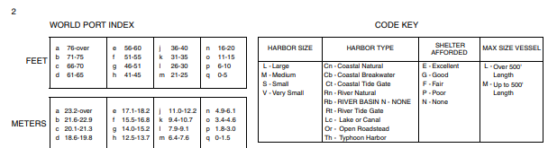

* Look up the meaning of *CargoDepth*

See above table.

The data from **US National Geospatial-intelligence** **(first shapefile)** agency is chosen based on its extensiveness.

**Trading Partners:**

All Trading partners are extracted based on the WITS Bulk download and used to extract data from the ComTrade API.

**Data is now extracted, but in a rather unstructured format. Need to now what format is preferred before moving on with this. Besides that, everything should be wrapped in one function, and saved as a PY file, which can be called alone and generate all the data.**

**What does the PY file need:**

**Level 2:**

Base the visualisation around the top five ports/airports.

**Ports data:** port0400.csv for individual data (ports0704 – found at least in TSGB)

We need to decide how we would like to show the data, in order to structure it correctly. Could be something like having a column for each layer.

**Airport data:** Table 13/14/15, depending on what the intention to show is. Table 13 as default.

The following definition explains the headers in table 14:

*Freight includes the weight of property carried on an aircraft including the weight of excess baggage and diplomatic bags, but excluding mail and passengers' and crews' permitted baggage. Freight in transit through the airport on the same aircraft is excluded.*

**Road data:** Road Freight: rfs0122/23, depending on the level of detail.

tra0102 contains data on *motor vehicle traffic* *by road class*, which could be useful if the MasterMap road layer contained annotations of road class, for at least the major roads to and from destination/origin of goods transported.  
We could approximate it from *rdl0202*, if MasterMap doesn’t contain the annotations.

**Level 1:**

Bicycle/Deliveroo/Uber? data